### ProjectReport

1. **INTRODUCTION**

### Overview

Clinic, an organized medical service offeringdiagnostic, therapeutic, or preventive outpatientservices. Often, the term covers an entire medicalteaching centre, including the hospital and theoutpatient facilities. The medical care offered by a clinicmayormaynotbeconnectedwithahospital.

## Purpose

The organization of a hospital clinic in generalfollowsthatoftheinpatientfacilities.Hospitalclinicsareprimarily concerned with acute diseases, and thephysicians in the clinics are usually the same physicianswhotreatinpatientsinthehospital

1. **ProblemsDefinition&DesignThinking**
   1. **Empathy Map**

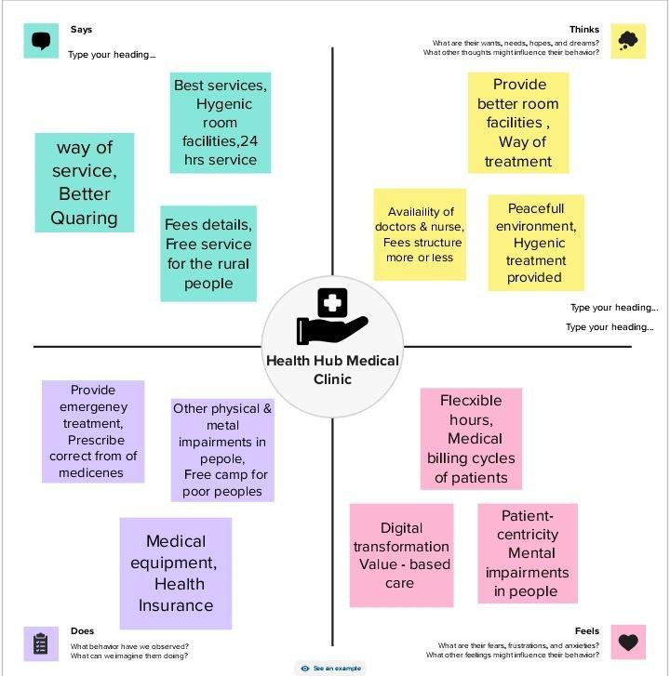

* 1. 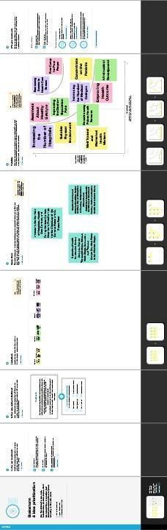**Ideation&BrainstormingMap**

1. **Result**

* Profit&Loss Account

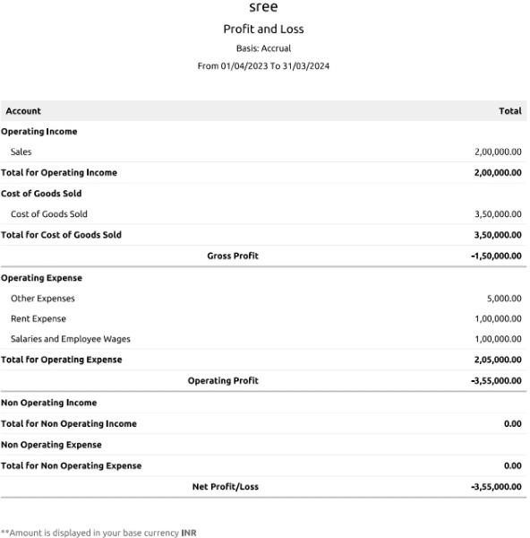

## Balancesheet

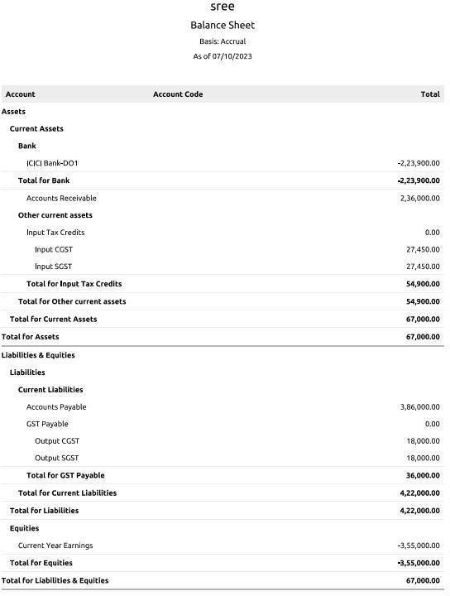

### ADVANTAGES&DISADVANTAGES

#### Advantages

* **overshospitalisationexpenses**
* **Coverspre-andpost-hospitalisationexpenses**
* **Coversdaycareprocedures**
* **Coversdomiciliarytreatments**
* **Coversalternativetreatment**
* **Coversannualhealthcheck-ups**
* **Offersadd-oncoverforcriticalillnesses**

#### DISADVANTAGES

* + **InadequateAccess**
  + **LowBudget**
  + **LackofPreventiveCare**
  + **LackofMedicalResearch**
  + **Policymaking**
  + **ShortageinProfessionals**
  + **PaucityofResources**

1. **APPLICATIONS**

ThenameofourClinicis:

HEALTHHUBMEDICALCLINIC

This clinic is located and applied in thefollowingaddress:

HEALTHHUBMEDICALCLINIC, South Street

Pandalgudi.

ContactNo:9923460015

Email[ID: healthhubmedicalclinic@gmail.com](mailto:ID:%20healthhubmedicalclinic@gmail.com)

# CONCLUSION

Inadequate healthcare is prevalentglobally in all countries, and no countryhas a perfect healthcare system. Healthis a basic human right, andimprovementsinhealthcareshouldbeagoalof everycountry.

7. FUTURESCOPE

The next wave of care emphasizes wellness andpreventive medicine, rather than primarilytreating and curing problems after they'vearisen.Thisfocuswillallowclinicianstoprovidemorepersonalizedcareplans,makingiteasier to diagnose rapidly and apply precisioncare when illness dose occur

8.APPENDIX

